# Part 1:

Write a program that calculates the total amount of a meal purchased at a restaurant. The program should ask the user to enter the charge for the food and then calculate the amounts with an 18 percent tip and 7 percent sales tax. Display each of these amounts and the total price.

## Flowchart, Pseudocode

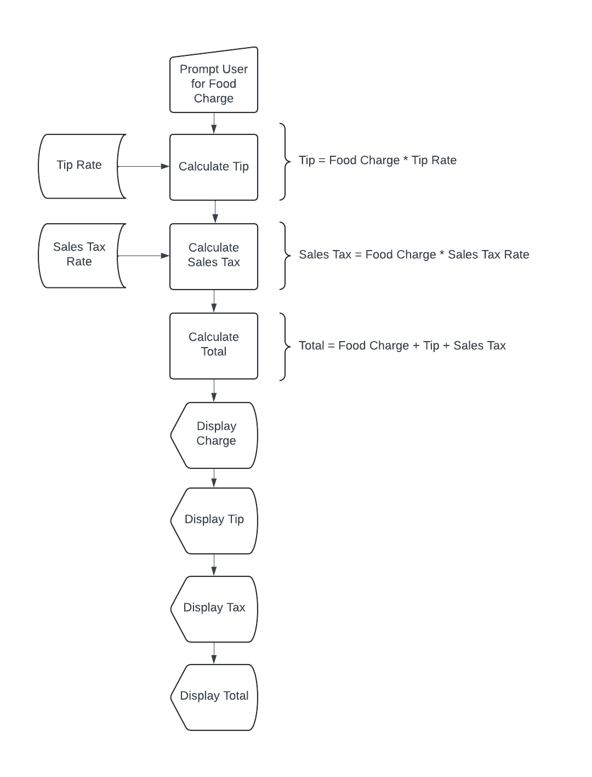

## Python Code

#Write a program that calculates the total amount of a meal purchased at a restaurant.

#The program should ask the user to enter the charge for the food and then calculate

#the amounts with an 18 percent tip and 7 percent sales tax. Display each of these amounts

#and the total price.

#initialize variables

CONST_tip_rate_per = 18.0

CONST_sales_tax_rate_per = 7.0

food_charge_dollars = 0.0

tip_dollars = 0.0

sales_tax_dollars = 0.0

total_charge_dollars = 0.0

#prompt for food charge and echo back

food_charge_dollars = float(input('Enter the total food charge in dollars and cents (do not include the $): '))

print('\nYou entered: ${:.2f}\n'.format(food_charge_dollars))

#calculate tip

tip_dollars = food_charge_dollars * (CONST_tip_rate_per/100)

#calculate sales tax

sales_tax_dollars = food_charge_dollars * (CONST_sales_tax_rate_per/100)

#calculate total charge

total_charge_dollars = food_charge_dollars + tip_dollars + sales_tax_dollars

#print report

print('Food Charge: ${:.2f}'.format(food_charge_dollars))

print('Tip: ${:.2f}'.format(tip_dollars))

print('Sales Tax: ${:.2f}'.format(sales_tax_dollars))

print('-----------------------')

print('Total: ${:.2f}\n'.format(total_charge_dollars))

## Output

# Part 2

Many people keep time using a 24-hour clock (11 is 11am and 23 is 11pm, 0 is midnight). If it is currently 13 and you set your alarm to go off in 50 hours, it will be 15 (3pm). Write a Python program to solve the general version of the above problem. Ask the user for the time now (in hours) and then ask for the number of hours to wait for the alarm. Your program should output what the time will be on a 24-hour clock when the alarm goes off.

## Flowchart, Pseudocode

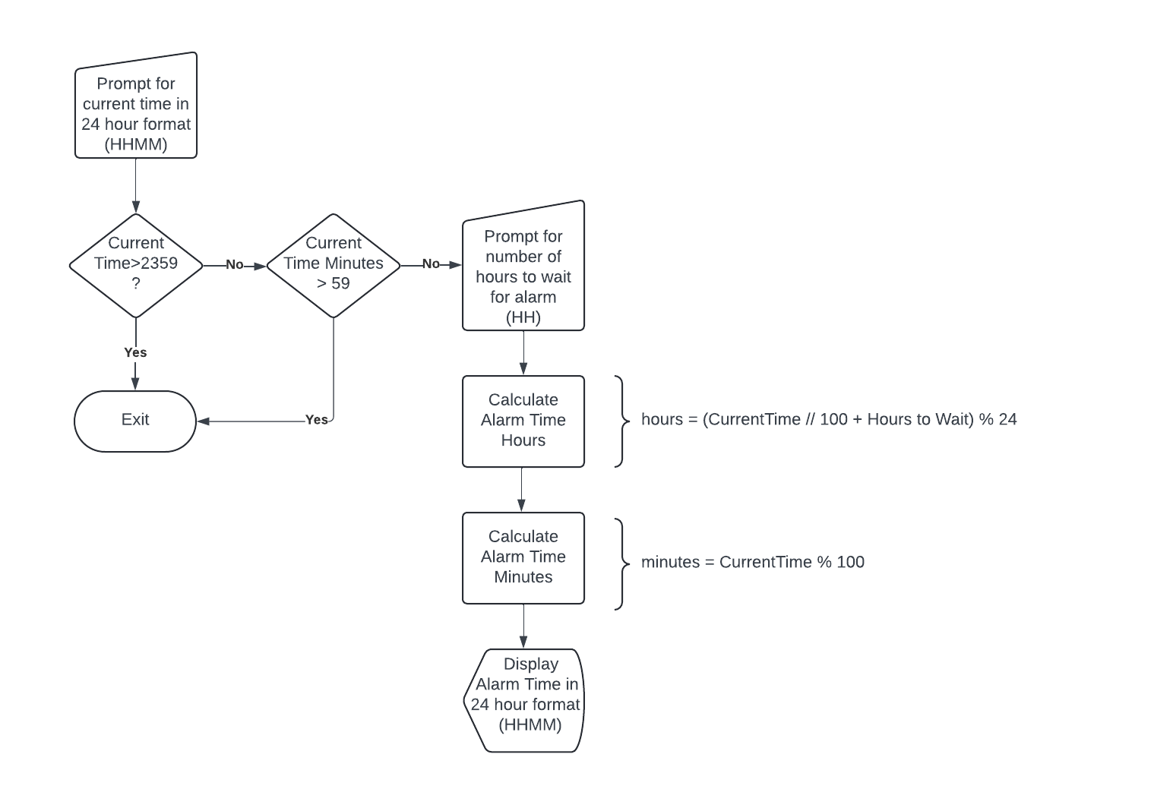

## Python Code

#Many people keep time using a 24-hour clock (11 is 11am and 23 is 11pm, 0 is midnight).

#If it is currently 13 and you set your alarm to go off in 50 hours, it will be 15 (3pm).

#Write a Python program to solve the general version of the above problem. Ask the user

#for the time now (in hours) and then ask for the number of hours to wait for the alarm.

#Your program should output what the time will be on a 24-hour clock when the alarm goes off.

#initialize variables

current_time_hhmm = 0

hours_to_wait = 0

alarm_time_hour = 0

alarm_time_minute = 0

#prompt for current time and check it is between 0 and 2400 and that the number of minutes is less than 60

current_time_hhmm = int(input('\nEnter the current time in HHMM format: '))

if current_time_hhmm < 0 or current_time_hhmm > 2359:

print('You entered an invalid time: {:d}, the program will exit.'.format(current_time_hhmm))

exit()

if current_time_hhmm % 100 > 59:

print('You entered an invalid number of minutes: {:d}, the program will exit.\n'.format(current_time_hhmm % 100))

exit()

#prompt for hours to wait and check if it is greater than 0

hours_to_wait = int(input('\nEnter the number of hours to wait: '))

if hours_to_wait <= 0:

print('You entered an invalid time to wait: {:d}, the program will exit.'.format(hours_to_wait))

#do calculations

alarm_time_hour = (current_time_hhmm // 100 + hours_to_wait) % 24

alarm_time_minute = current_time_hhmm % 100

#print out alarm time

print('\nThe alarm will occur at: {:d}{:02d}\n'.format(alarm_time_hour,alarm_time_minute))

## Output

